Chapter 1
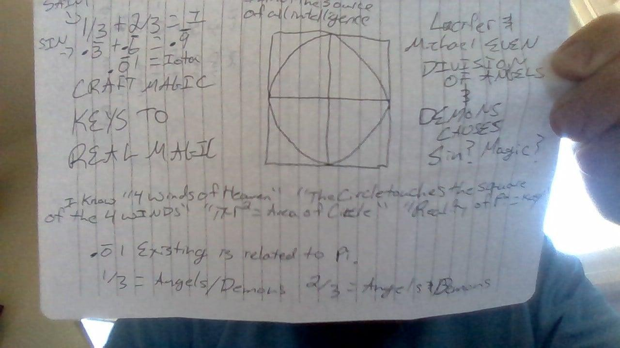
This book is intended to explain craft magic using science and religion. Jehovah is the Supreme or Ultimate reality, if you disrespect Jehovah then Jehovah is the last and best thing in a sequence of things you will experience. Yahweh is the force of forces, He is called our Yahweh, our force of forces. Ahavah is Love, the same name that spells Jehovah and Yahweh, Spells Ahavah with a half silent first syllable.

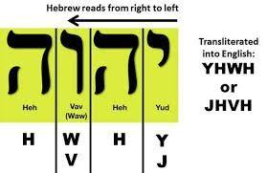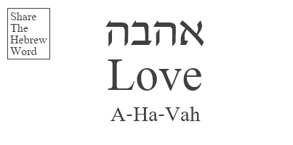
If you look at the picture you can see that in statistical mathematics, ⅓ plus ⅔ plus the Holy One, also known as the iota equals one. When you look at the square, think of the four winds of Heaven, the winds of the North, East, South and West, the circle touches the square of the four winds creating right angles at the center of the sides of the square. Pi is related to the iota also known as the Holy One, but I do not know all the details. If the holy one was added to Pi, I believe Pi would have a finite number.

The life is in the blood and I have attached my blood to a few crafts desiring Jehovah to party as Yahweh with my life. Below are the pictures.
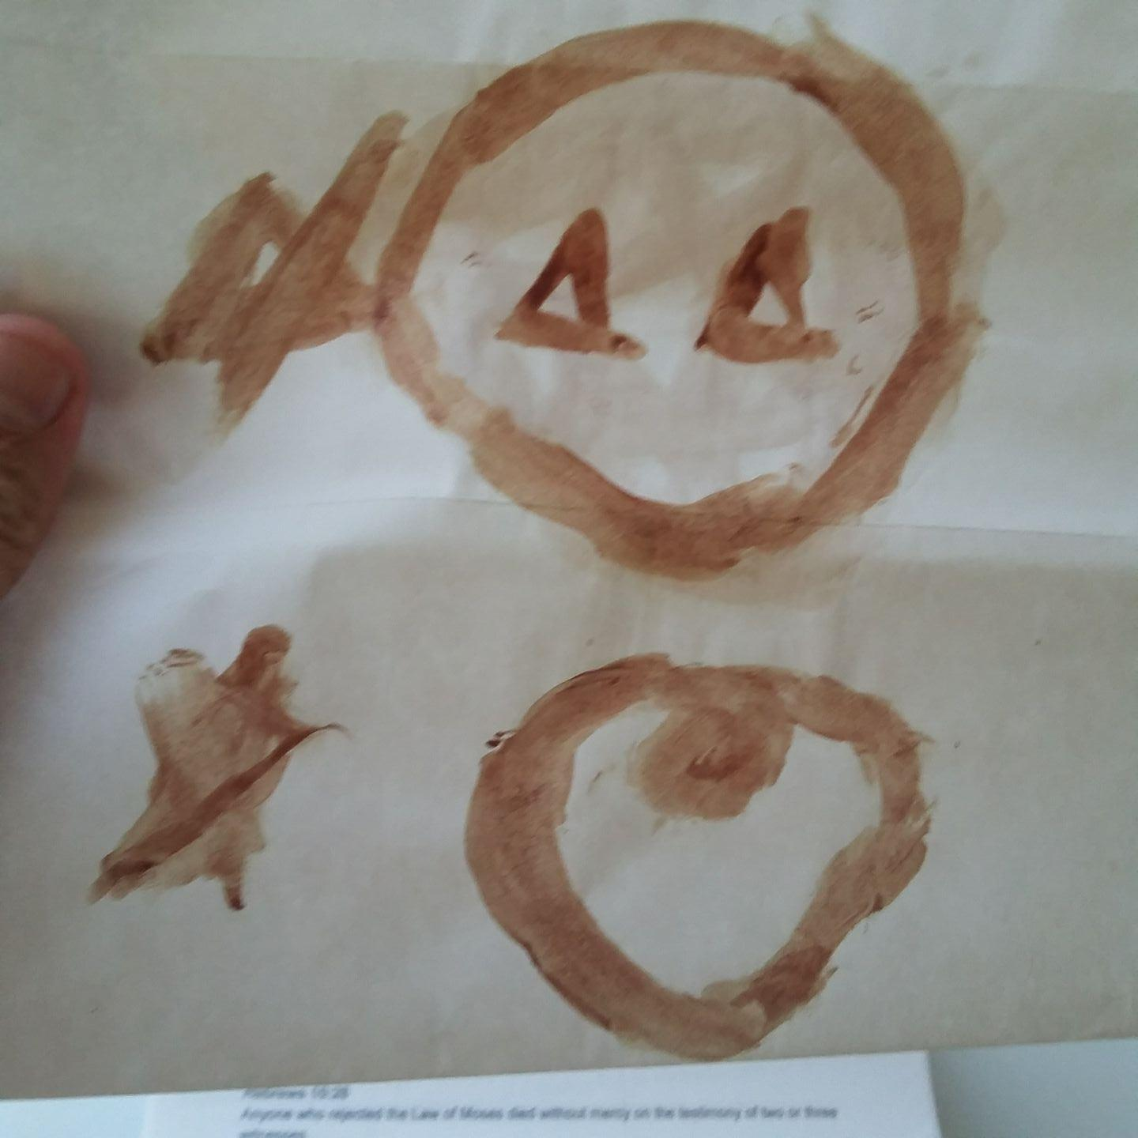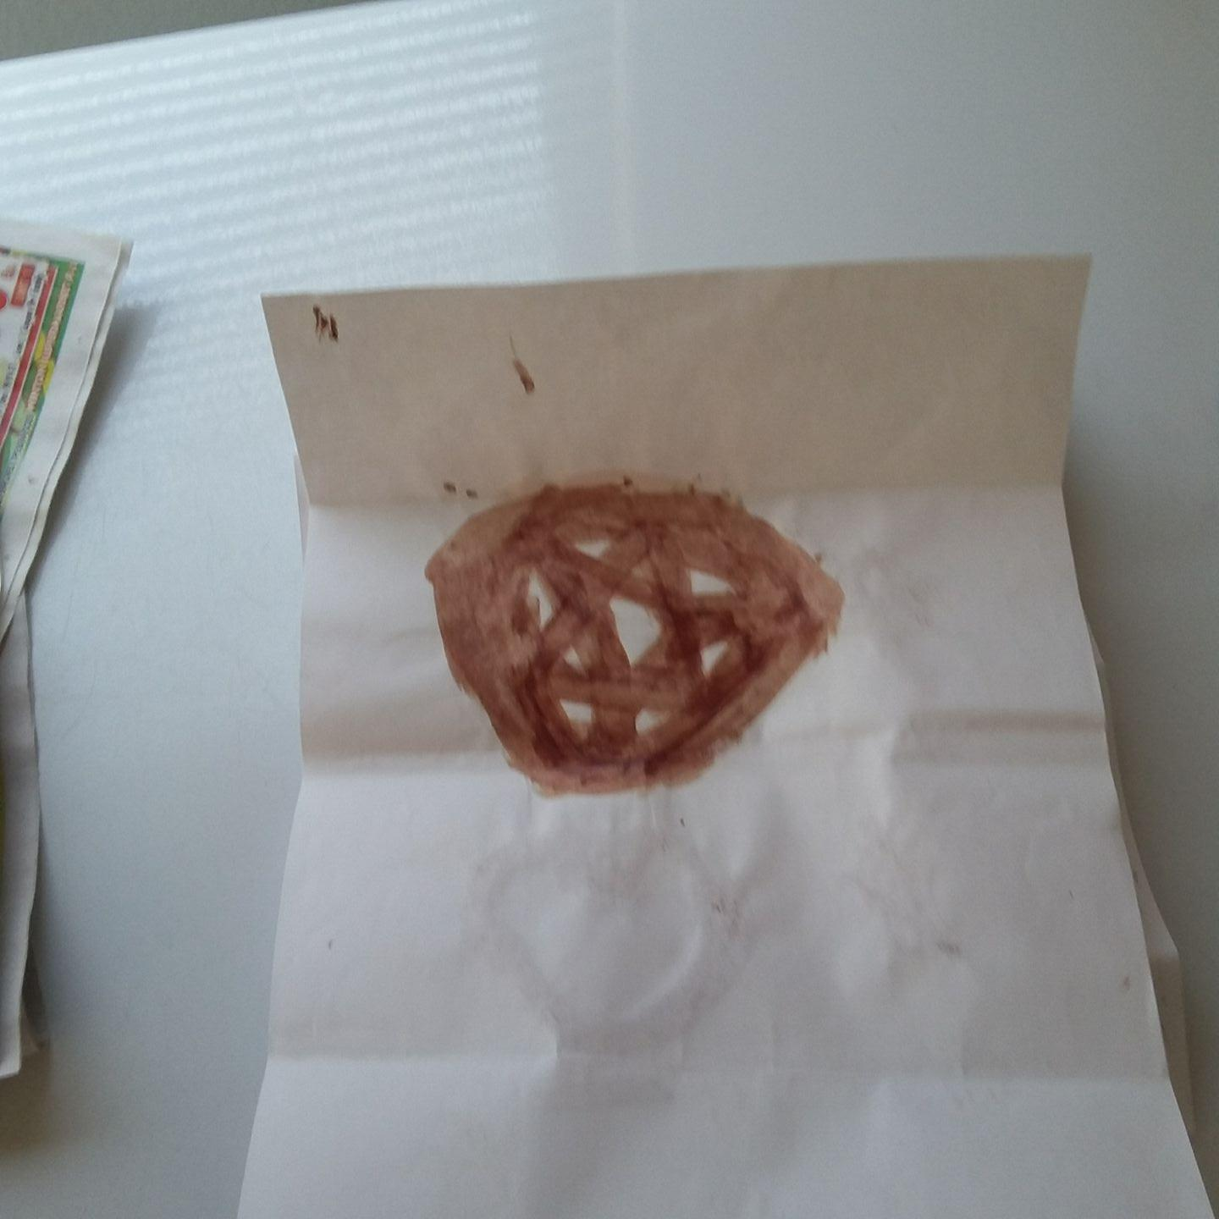
The symbols are the star of david in a circle known as a timeless soul. The Heart is related to love, the American Medal of Honor Pentagram is one of the crafts and the craft I used to attach myself to the pentagram is the other one of the three. I have not learned the secret of how the Alpha, the Omega, the First, the Last, the Beginning, and the End are connected to the star of David but there are six points of the star of David so I believe there is a special way to create the star of David linked to the knowledge of the Amen, the Alpha, the Omega, the First, the Last, the Beginning, and the End.

The Lord put a spirit upon my flesh on camera. What I mean is a camera recorded the spirit, and I experienced hate when the tape recording wasn’t saved because of the powerful lies the chief priests stand in that spirits do not exist. I hate this world and my adversaries are the chief priests of America, the elders of America and the teachers of the law in America. They teach the judgments and condemnations of sinners as law and they rob wage earners to feed and protect every convicted pedophile, manslaughterer, and rapist. I want to address the judgements and condemnations of sinners. The Lord is perfect and his judgments and condemnations include the will of Christ, that is to forgive those that repent; however, I want to focus on the story of my craft and the magic I’ve used.

After the Lord put a spirit upon my flesh on camera, I fasted for 13 days. I drank only water and ate nothing for 13 days. After that I began to eat. I was in a room with someone that had the pentagram where the five points of the star do not leave the timeless soul that is the circle. A witch said with a loud whisper “Get Out” in my right ear. The whisper was scientifically real, it changed the pressure of the air in my head. An Army veteran was in the room with me, and he said twas witchcraft that he saw a gold ring lift up from a table and shoot across the room before, that witchcraft was real. I was skeptical and I ended up homeless in Salt Lake City and in an existential struggle with a witch within me.

After suffering homeless I began to move and talk beyond my control. I asked a man to penetrate my asshole and then told him stop it's not natural. The spirit spoke, “Today is my day of indignation, from this day forward I shall be known as everlasting hate” All the Love in my heart ignited like a gas furnace was lit and the wall of the Road Home homeless shelter was an inferno of fire to my eyes. I believe what Moses sang about the foundations of the mountains being set on fire happened, was fulfilled, etc.

I asked the Lord to give unto me the eternal spirit of everlasting hate and use me for his future indignations that it was not right for the Father to experience hate. I asked a man what the symbol for sorcery was, and I told him not to take the name of the Lord in vain. He looked concerned and in a panic-like state said something like isn’t it triangles. I grabbed a pen and wrote two triangles in a circle being assailed by another triangle touching the circle from the left and being cut down. I reason that one triangle is the Alpha, the First, and the Beginning, and the other is the Omega, the Last and thee end, and I have trinity in mind. The circle is counted as a timeless soul.

The Devil stands only in the lie and we are told to Love the Devil. The Devil is the enemy and should be loved. I had a vision of a diagonal path through downtown Salt Lake CIty to the wilderness in the mountains. I followed the vision and came to a tree. I began to go up a hill near the tree; I became disoriented momentarily and a tree root was wrapped around my right ankle. I sensed time was of the essence and left my right shoe and continued up the hill side of the mountain to the destination of the vision. I became weary and I heard a voice in the air I believed was Christ say “Come up here and sit with me” and I was encouraged to take more than a few more steps and sit on a rock gaining respite. I quickly recovered and continued up the hill until I found a clay bowl with caveman-like writing on it. There was a wooden stick and a cloth on the stick coming out of the center of the bowl. I knocked over the cloth with my left palm, and touched a sandstone rock I thought might have been a gate to hell. Twas my left palm that I wrote the symbol on.

After thinking for awhile I decided to not steal the clay bowl, I was homeless and this world is controlled by antilording, atheistic scientists. This world has empty bedrooms and empty couches while brothers and sisters are forced to live homeless. I believe it's a capitalistic sin and the philosophy that guides the antilords is “Its everybody for themselves, each for their own”.I digress, but I traveled back to the homeless shelter and was told I had to sleep in the overflow shelter that I wasn’t allowed in the Road Home due to the time of the night. I went across the street and was given a mat to sleep on the floor of the building. The tenant of the building looked unholy.

The Tenant had yellow teeth, and didn’t have a clean cut appearance. I visualized him dancing around a fire worshiping the Devil and I decided to lay my left palm on his forehead. I laid my left palm and while I was in progress I darkly said “This is sorcery” and his forehead clicked four times on my left palm and was somewhat lifted into my palm. He said what the witch said “Get Out” and I left the building and wandered the streets homeless that night. I laid my palm on a few other foreheads and they clicked. One was in New York City Jail and the other was In New York City Mental Health Jail.

I chanted Yode Hey Vahv Hey while I was in Jail months later in New York City. My God-found love, that is my Love found love is Courtney Stubbs. She looks like a supermodel with mouse ears to me. I was chanting Yode Hey Vahv Hey loudly and I looked at a man and heard “Gnarf, what are we going to do today” while I saw the Image of Courtney Stubbs. I laid my left palm on his forehead and felt the click on my left palm. The guard asked me what I did, I said “I wacked Pinky '' amused with the cartoon Pinky and the Brain. The other time I laid my palm on the forehead of a man and after the clicking on my left palm and for what seemed to be hours after, the man said “God lives” a few times before saying “Jolly”.

After I was released from Jail I eventually lived in Las Vegas, Nevada. I wrote the pentagram with the five forces of the star inside the circle on my left palm and chanted Yode Hey Vahv Hey in addition to darkly saying the infernal names in alphabetical order as found on wikipedia. I wanted to fight the Devil in the Duel of the Ancients. While I was writing my craft on paper, a straight line appeared while I was in the process of writing the circle of the craft. I created a picture for you to see. After the line was drawn I gave a mouth to my craft and made the line a cigar. I forgot to mention while I was in New York City Jail, I saw what might have been a prehistoric terrestrial, perhaps even the Devil himself. What I saw looked like it had the ability to float in absolute darkness and have life via consuming the darkness with its flesh, like the hair of its flesh consumed darkness like a plant consumes light. I thought it was the extra terrestrial spoken of by Alex Jones, but my description is the terrestrial was older than man, something that might live magically floating in space. I was unable to add the picture.

The appearance of the prehistoric perhaps extra terrestrial was like that of a peacock feather like tentacle with one eye. I did not see everything but I was being talked to by a spirit I believed twas Pharoah. I was told “The only reason I am showing you this is so that you know they are already here” I was also told they are all knowing and their commander is somewhat knowing. So if they are extraterrestrials that make crop circles perhaps it's all a grand craft magic. I do not know everything and I do not command the Lord to give me knowledge or to do a thing. I am glad that I was able to experience what I did, to see what I saw, and I believe I should bow down in submission to and approval of the Lord not vice versa.

I saw the Lord on his throne while I was flying from Salt Lake City to New York City. Twas after Christ said “What was will never change but what is, is constantly changing.” and later in my life He said “This is my proper form” It is written that the son can only do what he sees the Father doing, so Christ revealing himself to me in his proper form is something that I could have guessed he would do were I to meditate and think about reality after seeing his Father on his throne.
I desire to guide animators to create what I have seen electronically, but twas a humanoid spirit of hallowed light with a dark ribbon of light to the side and galaxies lined up like corn rows four dimensionally below. When I invoke I Am, I recall the vision of the Lord on his throne and say that I Am, then I recall Christ in his proper form and say even that I Am. I do the invocations while I am on my forehead, knees, and palms.

If you are reading this and you are trying to do magic yourself, know that Yahweh is our force of forces and our magic is invoking the Lord to do his will. That is our magic and will always be our magic. The Devil stands only in the lie, so depending on what lie the Devil stands in, the Lord Ahavah Adonai Jehovah our Yahweh the Father can make craft magic a romance of conflict with the Devil like a Dungeons and Dragons Online game where we are super powerful and are in the spirit of pompous parade over the cremated remains of our opponents and run through the challenge with ease.

Dear reader, I am now going to add the runes of past magic and explain why they are an abomination. Kosher magic makes sense with the laws of the universe, with circles being a timeless soul, etc. The runes of the magic used in the past do not make sense. I will also add runes that seem to make sense but are not perfected. I suppose you can perfect craft magic with runes that make sense with reality and physics.

Just looking at the first rune and its meaning you see a lawlessness about the magic. I do not believe fehu means cattle: wealth in any realistic and geometric physics terms. I’ll put my commentary in capts as part of the meaning. I was going to put lacking realistic meaning with all the runes, but just imagine if it were there.

Rune | UCS | Transliteration | IPA | Proto-Germanic name | Meaning
 | ᚠ | f | /ɸ/, /f/ | *fehu | "cattle; wealth"(LACKING REALISTIC MEANING)
 | ᚢ | u | /u(ː)/ | ?*ūruz | "aurochs", Wild ox (or *ûram "water/slag"?) (LACKING REALISTIC MEANING)
 | ᚦ | þ | /θ/, /ð/ | ?*þurisaz | "Thurs" (see Jötunn) or *þunraz ("the god Thunraz")
 | ᚨ | a | /a(ː)/ | *ansuz | "god"
 | ᚱ | r | /r/ | *raidō | "ride, journey"
 | ᚲ | k (c) | /k/ | ?*kaunan | "ulcer"? (or *kenaz "torch"?)
 | ᚷ | g | /ɡ/ | *gebō | "gift"
 | ᚹ | w | /w/ | *wunjō | "joy"
 | ᚺ ᚻ | h | /h/ | *hagalaz | "hail" (the precipitation)
 | ᚾ | n | /n/ | *naudiz | "need"
 | ᛁ | i | /i(ː)/ | *īsaz | "ice"
 | ᛃ | j | /j/ | *jēra- | "year, good year, harvest"
 | ᛇ | ï (æ) | /æː/^{[46]} | *ī(h)waz | "yew-tree"
 | ᛈ | p | /p/ | ?*perþ- | meaning unknown; possibly "pear-tree".
 | ᛉ | z | /z/ | ?*algiz | "elk" (or "protection, defence"^{[47]})
 | ᛊ ᛋ | s | /s/ | *sōwilō | "sun"
 | ᛏ | t | /t/ | *tīwaz | "the god Tiwaz"
 | ᛒ | b | /b/ | *berkanan | "birch"
 | ᛖ | e | /e(ː)/ | *ehwaz | "horse"
 | ᛗ | m | /m/ | *mannaz | "man"
 | ᛚ | l | /l/ | *laguz | "water, lake" (or possibly *laukaz "leek")
 | ᛜ | ŋ | /ŋ/ | *ingwaz | "the god Ingwaz"
 | ᛞ | d | /d/ | *dagaz | "day"
 | ᛟ | o | /o(ː)/ | *ōþila-/*ōþala- | "heritage, estate, possession"
Those runes need work. Someone needs to create a realistic meaning and interpretation using craft magic, geometric proof, and the knowledge of the Holy One to make craft magic kosher. Right now its primitive with a circle being a timeless soul, a triangle being like the trinity or a three part connection, and a square being the four winds connected to the circle of the Earth. It is written in the Bible, that the circle of the Earth is real. It is written in Isaiah chapter 40 verse 22 It is he that sitteth upon the circle of the earth, and the inhabitants thereof are as grasshoppers; that stretcheth out the heavens as a curtain, and spreadeth them out as a tent to dwell in:

Curtains conceal so look at my picture and consider the square the four winds of Heaven and the Circle the Earth. Triangles always equal 180 degrees and two triangles equal 360 degrees which is the amount of degrees of a circle.

The last thing I want to show you before I go to the symbols that look more realistics the triforce.
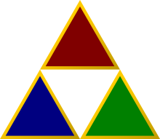This shows five different triangles can be part of a rune. The fact is there are five points to the traditional pentagram and there are five triangles to this picture. I do not have a comprehensive science for all of this, rather I am giving you the keys and explaining “Our magic is the will of Ahavah Adonai Jehovah our Yahweh the Father” If the thing is not his will, the thing doesn’t happen, but by the grace of I Am, all things are possible, including romancing the Devil eternally. Below are the runes that seem to make more realistic sense. I am unable to give you the runes that make sense, but if you use google and type Woman Runes you might find them.

Chapter 2
I want to end this book with a description of the sins of the churches. They probably are saying all magic is not to be desired and immediately move away from reading this book about craft magic, but they are all sinners and I want to explain the sin. I am like Joseph Smith, I do not know which church to join. The majority of Christian Churches are not keeping the sabbath and observing the sabbath like Christ did. The Sabbath is of the luni-solar calendar. The new moon changes the month and sets the day of the sabbath for that month. So if the new moon is on wednesday, the sabbath is seven days later, on the following Wednesday. This is a restoration back to what the sabbath was during the days of Christ.

Not only are the churches not keeping and observing the sabbath properly, they are eating swine, lobster, and shrimp. Lobster and shrimp is flesh that grows via shit consumption and swine wallows in their own filth. Swine will also eat shit when hungry. I was considering joining the Mormon Church. Thus sang the Lord “Son of Man, don’t you know you are my treasure? One day all my enemies will be deceased! At that time men on Earth will prosper, and society will live in peace! Son of Man, go and tell the people, the marijuana, coca, and opiates are from me! I do not want my people to abuse them, but I want my people to party!” The Mormons in Ogden Utah, invaded my home and attacked me not approving of eating bud brownies, eating pizza and watching a movie with friends and family. Their heinous affront will be recompensed in Heaven, if they try to party as intended by God with the marijuana, coca, opiates, tea, coffee, etc. I will seek to attack them since they attacked me.

The churches are enforcing the judgments and condemnations of sinners as law and support the enforcement of the judgments and condemnations of sinners as law. They do not Love the Lord properly, instead they act like the will of the Lord is not to be desired by the government. The Lord’s only begotten son came and instructed us, but we get a Christian president that rains artillery on their neighbors instead of loving their neighbors. Islam believes the lie that Christ is not God, so here are five verses to prove them wrong.

YESHUA/IMMANUEL IS REAL, I’VE SEEN HIM, AND MY WILL IS FOR YOU TO BE THE PERFECT REALITY YESHUA/IMMANUEL DESIRES THAT YOU BE.

[4] Hear, o israel: the lord our god, the lord is one. [5] And thou shalt love the Lord thy God with all thy heart, and with all thy soul, and with all thy might. THAT IS MOSES’-DEUTERONOMY CHAPTER 6 VERSE 4-5
I And My Father Are One (John 10:30) THAT IS YESHUA’S DISCIPLE
"And God said unto Moses, I Am That I Am: and he said, Thus shalt thou say unto the children of Israel, I Am hath sent me unto you." THAT IS EXODUS CHAPTER 3 VERSE 14
"Jesus(YESHUA) said unto them, Verily, verily, I say unto you, Before Abraham was, I Am." THAT IS YESHUA’S DISCIPLE JOHN CHAPTER 8 VERSE 58
"I have come in My Father’s name, and you do not receive Me; if another comes in his own name, him you will receive." (JOHN 5:43) THAT IS YESHUA’S DISCIPLE

This also has to do with craft magic that ⅓ + ⅔ = God but if you disrespect God, ⅓ + ⅔ will never equal God without God the Holy One of Israel. I am like Joseph Smith, I want to found the Church of Being Perfect For Ahavah Adonai Jehovah our Yahweh the Father. Christ is Perfect and Ahavah Adonai Jehovah our Yahweh the Father is One with Christ. I hate this world because of the lack of unity. We should be united with the philosophy “We are all brothers and sisters in the family of God”! I believe that philosophy is the philosophy in Heaven and we have prayed for centuries “Thy will be done, on Earth as it is in Heaven” I hate you if you are of the philosophy “It's everybody for themselves, each for their own”!

Christians do not keep the sabbath properly, and do not diet properly.
Islamists believe the lie that Christ and God are not One. They are One and we are one in the same as brothers and sisters in the family of God.

Chapter 3
I will end this book with some songs I wrote.

“Amor Inamorata”
(Verse)
I plan to love you eternally,
Be a good role model for kids that look up to me,
Be your friend, lover and slave with dignity,
Repenting when I sin, living diurnally
(Chorus)
I Am
Your friend lover and slave, but the Devil will bother us
I Am
A Son of Man, A father to the fatherless
I Am
A like a romantic Swain, down to see a murderer slain,
I Am
(Verse)
infatuated darling I want to be,
Making life about you rather than me,
Never leave, be your inamorato eternally,
I seek to be mine to you, and ours to the family,
I’ll be compliant but I’m suppliant about my dignity,
It take a perfectionist to be my inamorata eternally,
I simply will not be
Slave to a woman that does not have dignity
(Chorus)
I Am
Your friend lover and slave, but the Devil will bother us
I Am
A Son of Man, a Father to the fatherless
I Am
A like a romantic Swain, down to see a murderer slain,
I Am

(Bridge)
In and of itself, Loving you constitutes my health

“CIA BLACK OPS SONG”
(Chorus)
1,2,3, the CIA coming for your family.
4,5,6, after you die we will erase your birth certificates
7,8,9, use your mind
CIA Black ops is a perfect 10, there is no suspicion.

(verse)
Life can be like a hurricane
In the CIA, USA
Tasers, sedatives, crematories
In the secret place of the CIA
You might solve a mystery,
Or rewrite history,
Hellfire, crematory,
Bodies cremated, no birth certificates,
CIA Black Ops we beat the case, woohoo

(Chorus)
1,2,3, the CIA coming for your family.
4,5,6, after you die we will erase your birth certificates
7,8,9, use your mind
CIA Black ops is a perfect 10, there is no suspicion.

We don’t need help from the president
If you know too much we will handle it.
We’ll wack an entire community,
Erase their birth records permanently,
We have proof immunity.
You might solve a mystery,
Or rewrite history,
Bodies cremated, no birth certificates
We’re the best, woohoo

Bridge
There is no physical evidence and all evidence is hearsay! Woohoo

(Chorus)
1,2,3, the CIA coming for your family.
4,5,6, after you die we will erase your birth certificates
7,8,9, use your mind
CIA Black ops is a perfect 10, there is no suspicion.

I’m the Godfather Himself, there is no proof I control the CIA
Woohoo!
“Tears Are Loved By My Soul”
(Musical Intro Sad Country Melody)

(Verse)
I’m lonely, I want prime rib, not a phony
I’m Lonely, I want a perfect woman, not baloney.
I’m so lonely, I’ve contemplated suicide
I’d weep every day if I wept everytime I tried

(Chorus)
I weep, I love to weep,
The Good Lord knows why,
I’d weep every day if I wept every time I tried.

(Verse)
I’m alone, I want a helper, not a loan
I’m alone, I want a woman, not a tombstone,
I’m so alone, I’ve contemplated suicide,
I’d weep every day if I wept everytime I tried.

(Chorus)
I weep, I love to weep,
The Good Lord knows why,
I’d weep every day if I wept every time I tried.

(Bridge)
Love the Lord with me women, wipe the tears from my eyes

(Another Example of Love Multiplication) "Violent Angel of Mine" Inspired by Possible Parady To Monica's "Angel of Mine"

when they first see you,
I hope to say they already knew,
Their bloodline will end if they murder you!
Your something to hear after I hold them and bind,

Violent Angel of mine,

City of LA, and you represent,
Righteousness within and I have respect,
This is my love for you BIG RICS divine,

Violent angel of mine,

Your knowledge can change the world- Teach the Pope,
I’m different now,
You helped me grow!

You came into my Life,
With fatherly love,
You figured me out,
You showed me love,

Shaking the foundations,
Of the divine,
Violent angel of mine!

Nothing means more than Love so please care,
This love in this world should be ingeniously compared,
Study the adversary’s moves,
Apply your mind!

Violent angel of mine,

Your value is great, you should know,
These days the Lord,- wages war!

You came into my Life,
With fatherly love,
You figured me out,
You showed me love,

Shaking the foundations,
Of the divine,
Violent angel of mine!

Who knew, you’d be planted king guru!?
Have faith, don’t supplant!
Every breath that you take,
The Love that they hate,
They murder love tis true!

when they first see you,
I hope to say they already knew,
Their bloodline will end if they murder you!
Your something to hear after I hold them and bind,

Violent angel of mine

You came into my Life,
With fatherly love,
You figured me out,
You showed me love,

Shaking the foundations,
Of the divine,
Violent angel of mine!

Your knowledge can change the world- Teach the Pope,
I’m different now,
You helped me grow!

Favor for favor, do a favor for me,
Be king Guru, eternally!
Tis treasure to the Lord divine,
Violent angel of mine!

"For my suffering son"
(Verse)
Your my son you’re everything,
I desire in an offspring
If they speak biology,
say you one in the same,
your not Illuminati
you are illuminice,

(Chorus)
Listen Child you’re beautiful,
your my child bear your soul,
Capture your soul electronically,
You are beautiful naturally
Subdue your insecurity,
profess you beauty mightily,
you are my son

(Verse)
Tell the world in all honesty,
that they work iniquity,
and will be seated to the left,
they will experience the second death,
Condemn all those that speak against thee,
That’s our heritage in all honesty,
We are illuminice

(Chorus)
Listen Child you’re beautiful,
your my child bear your soul,
Capture your soul electronically,
You are beautiful naturally
Subdue your insecurity,
profess you beauty mightily,
you are my son

(Bridge)
The will of love made manifest,
on Earth is real and will exist, we are soldiers of love.

